*db.Restaurants.insertOne({"address":{"building":"23,Arkham","street":"drive32","zip-code":402589},"type_of_restaurant":"Bakery","cuisine":["pastry","dessert"],"state":"oklahoma","grades":[{"date":{"$date":1393804800000},"grade":"A","score":2},{"date":{"$date":1378857600000},"grade":"B","score":10}],"name":"Park Bake Shop","restaurant_id":"3000789655"})*

**

*db.Restaurants.insertOne({"address":{"building":"16,NewPort","street":"times square","zip-code":454589},"type_of_restaurant":"Bakery","cuisine":["pastry","Snacks"],"state":"Buckingham","grades":[{"date":{"$date":1393808800000},"grade":"B","score":2},{"date":{"$date":1376857600000},"grade":"A","score":8}],"name":"Gupta Bake Shop","restaurant_id":"300078755"})*

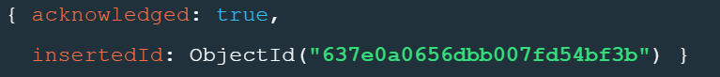

*db.Restaurants.insertOne({"address":{"building":"21,NewPort2","street":"Rome Wally","zip-code":4459},"type_of_restaurant":"Bakery","cuisine":["Italian","Sweets"],"state":"Texas","grades":[{"date":{"$date":1393578800000},"grade":"B","score":10},{"date":{"$date":1376587600000},"grade":"A","score":13}],"name":"Green Sweet Shop","restaurant_id":"30007654"})*

**

*db.Restaurants.insertOne({"address":{"building":"45,NewYard","street":"thunderValley","zip-code":403204},"type_of_restaurant":"Food Bar","cuisine":["French cuisine","Sweets"],"state":"san andreas","grades":[{"date":{"$date":1343858800000},"grade":"A","score":8},{"date":{"$date":13764666600000},"grade":"A","score":12}],"name":"Sweet Corners ","restaurant_id":"78845421"})*



